 

**PANIMALAR INSTITUTE OF TECHNOLOGY**

PROJECT REPORT

**NEWS TRACKER APPLICATION**

**DONE BY**

**TEAM ID: PNT2022TMID25772**

**ADHI T (211519104007)**

**ALTHAF HUSSAIN A (211519104015)**

**GOPINATH M (211519104046)**

**MANIKANDAN K (211519104081)**

1. **INTRODUCTION**
   1. Project Overview
   2. Purpose
2. **LITERATURE SURVEY**
   1. Existing problem
   2. References
   3. Problem Statement Definition
3. **IDEATION & PROPOSED SOLUTION**
   1. Empathy Map Canvas
   2. Ideation & Brainstorming
   3. Proposed Solution
   4. Problem Solution fit
4. **REQUIREMENT ANALYSIS**
   1. Functional requirement
   2. Non-Functional requirements
5. **PROJECT DESIGN**
   1. Data Flow Diagrams
   2. Solution & Technical Architecture
   3. User Stories
6. **PROJECT PLANNING & SCHEDULING**
   1. Sprint Planning & Estimation
   2. Sprint Delivery Schedule
7. **CODING & SOLUTIONING (Explain the features added in the project along with code)**
   1. Feature 1
   2. Feature 2
   3. Database Schema (if Applicable)
8. **ADVANTAGES & DISADVANTAGES**
9. **CONCLUSION**
10. **FUTURE SCOPE**
11. **APPENDIX**

Source Code

Live Page Url

# INTRODUCTION

* 1. **Project Overview**

NewsTracker is a fullstack web application which allows users to register along with their favourite topics, upon login the app displays the news based on the user’s interest. The news displayed in the app is based on the Newcatcher API and Cricbuzz API from Rapid API site.A news-sharing app wants to help users find relevant and important news easily every day and also provide explicitly news from that users locality/region which may of help to the user.

# Purpose

Enabling users to view news from anywhere at anytime. It also helps to reduce the time to get information about a specific topic. Also enables a person to get an updated news which may help Business people to make business related decisions quickly and correctly.

# LITERATURE SURVEY

* 1. **Existing problem**

Physical newspapers are old fashioned in this digital era. They cost money to buy, can easily be damaged, limited amount of information, not flexible to modifications, poor quality. Sometimes may show unrelevant and updated news.

# References

|  |  |  |  |  |  |
| --- | --- | --- | --- | --- | --- |
| **S.**  **no** | **Paper title** | **Author** | **Published date** | **Implementation** | **Resource link** |
| 1 | Following the Fed with a News Tracker | Michael William McCracken | January, 2012 | The paper is not a technical paper but is essentially a statistical paper on how should one conclude whether the data have come in stronger, weaker  or as expected. This is based on the CitiGroup U.S Economic Surprise Index. | [(PDF)](https://www.researchgate.net/publication/227438253_Following_the_Fed_with_a_News_Tracker)  [Following](https://www.researchgate.net/publication/227438253_Following_the_Fed_with_a_News_Tracker) [the Fed](https://www.researchgate.net/publication/227438253_Following_the_Fed_with_a_News_Tracker) [with a News](https://www.researchgate.net/publication/227438253_Following_the_Fed_with_a_News_Tracker) [Tracker](https://www.researchgate.net/publication/227438253_Following_the_Fed_with_a_News_Tracker) [(researchga](https://www.researchgate.net/publication/227438253_Following_the_Fed_with_a_News_Tracker) [te.net)](https://www.researchgate.net/publication/227438253_Following_the_Fed_with_a_News_Tracker) |
| 2 | Topic Detection and Tracking in News Articles | Sagar Patel, Sanket Suthar, Sandip Patel, Neha Patel | March, 2015 | 1. Pre-processing 2. Tokenization 3. Stemming/Lemmization 4. Vector Space Model 5. Topic tracking | [(PDF) Topic](https://www.researchgate.net/publication/315657099_Topic_Detection_and_Tracking_in_News_Articles) [Detection](https://www.researchgate.net/publication/315657099_Topic_Detection_and_Tracking_in_News_Articles) [and](https://www.researchgate.net/publication/315657099_Topic_Detection_and_Tracking_in_News_Articles) [Tracking in](https://www.researchgate.net/publication/315657099_Topic_Detection_and_Tracking_in_News_Articles) [News](https://www.researchgate.net/publication/315657099_Topic_Detection_and_Tracking_in_News_Articles) [Articles](https://www.researchgate.net/publication/315657099_Topic_Detection_and_Tracking_in_News_Articles) [(researchga](https://www.researchgate.net/publication/315657099_Topic_Detection_and_Tracking_in_News_Articles) [te.net)](https://www.researchgate.net/publication/315657099_Topic_Detection_and_Tracking_in_News_Articles) |
| 3 | An  End-to-end Weakly- supervised News Aggregation Framework | Xijin Tang, Xiaohui Huang | June, 2022 | The framework combines Snorkel based weakly Supervised classification, Latent Dirichlet Allocation (LDA) topic modeling, and topic signal detection model to classify and aggregate unlabeled news texts and ultimately generate visualized results containing news categories, news topics, and temporal topic relationships. This paper uses constructed knowledge thesaurus and the Snorkel method to weakly supervise the classification of unlabeled news with no manual tagging. Subsequently, we utilize LDA to generate the topics and | [An](https://www.researchgate.net/publication/361087328_An_End-to-end_Weakly-supervised_News_Aggregation_Framework)  [End-to-end](https://www.researchgate.net/publication/361087328_An_End-to-end_Weakly-supervised_News_Aggregation_Framework) [Weakly-supe](https://www.researchgate.net/publication/361087328_An_End-to-end_Weakly-supervised_News_Aggregation_Framework) [rvised News](https://www.researchgate.net/publication/361087328_An_End-to-end_Weakly-supervised_News_Aggregation_Framework) [Aggregation](https://www.researchgate.net/publication/361087328_An_End-to-end_Weakly-supervised_News_Aggregation_Framework) [Framework |](https://www.researchgate.net/publication/361087328_An_End-to-end_Weakly-supervised_News_Aggregation_Framework) [Request PDF](https://www.researchgate.net/publication/361087328_An_End-to-end_Weakly-supervised_News_Aggregation_Framework) [(researchga](https://www.researchgate.net/publication/361087328_An_End-to-end_Weakly-supervised_News_Aggregation_Framework) [te.net)](https://www.researchgate.net/publication/361087328_An_End-to-end_Weakly-supervised_News_Aggregation_Framework) |

|  |  |  |  |  |  |
| --- | --- | --- | --- | --- | --- |
|  |  |  |  | obtain the signal value of each topic based on the topic signal detection function. Finally, we establish the temporal topic relationships and get the visualized results of news aggregation. |  |
| 4 | Exploring mobile news reading interactions for news app personalisati on | Marios  Constantinides  ,John Dowell , David Johson, Sylvain Malacria | August, 2015 | 1. Identification of news reader types 2. Interaction logging and classification study 3. Deployment and data collection 4. Predicting News reader types 5. Adaptive UI | [(PDF)](https://www.researchgate.net/publication/299870645_Exploring_mobile_news_reading_interactions_for_news_app_personalisation)  [Exploring](https://www.researchgate.net/publication/299870645_Exploring_mobile_news_reading_interactions_for_news_app_personalisation) [mobile news](https://www.researchgate.net/publication/299870645_Exploring_mobile_news_reading_interactions_for_news_app_personalisation) [reading](https://www.researchgate.net/publication/299870645_Exploring_mobile_news_reading_interactions_for_news_app_personalisation) [interaction](https://www.researchgate.net/publication/299870645_Exploring_mobile_news_reading_interactions_for_news_app_personalisation) [s for news](https://www.researchgate.net/publication/299870645_Exploring_mobile_news_reading_interactions_for_news_app_personalisation) [app](https://www.researchgate.net/publication/299870645_Exploring_mobile_news_reading_interactions_for_news_app_personalisation) [personalisa](https://www.researchgate.net/publication/299870645_Exploring_mobile_news_reading_interactions_for_news_app_personalisation) [tion](https://www.researchgate.net/publication/299870645_Exploring_mobile_news_reading_interactions_for_news_app_personalisation) [(researchga](https://www.researchgate.net/publication/299870645_Exploring_mobile_news_reading_interactions_for_news_app_personalisation) [te.net)](https://www.researchgate.net/publication/299870645_Exploring_mobile_news_reading_interactions_for_news_app_personalisation) |
| 5 | Innovative Application For News Tracker | Dr.C.K.Goma thy, Dr.V.Geetha, Peddireddy Abhiram, Marios Constantinid es | Septembe r , 2020 | This paper aimed at developing an online news management system that is of information to either a college. Online news management system provides a simple interface for maintenance of college information. The creation management of accurate,up-to-date information regarding to college.The main objective for developing this project is provide all the functionality related to latest news and it  tracks. | [(PDF) The](https://www.researchgate.net/publication/344241661_The_Innovative_Application_for_News_Management_System)  [Innovative](https://www.researchgate.net/publication/344241661_The_Innovative_Application_for_News_Management_System) [Application](https://www.researchgate.net/publication/344241661_The_Innovative_Application_for_News_Management_System) [for News](https://www.researchgate.net/publication/344241661_The_Innovative_Application_for_News_Management_System) [Management](https://www.researchgate.net/publication/344241661_The_Innovative_Application_for_News_Management_System) [System](https://www.researchgate.net/publication/344241661_The_Innovative_Application_for_News_Management_System) [(researchga](https://www.researchgate.net/publication/344241661_The_Innovative_Application_for_News_Management_System) [te.net)](https://www.researchgate.net/publication/344241661_The_Innovative_Application_for_News_Management_System) |

* 1. **Problem Statement Definition**

Newspaper contains limited , non user/reader specific, Location specific news

. There are multiple news-sharing apps available which can be used by a single user and are often spammed with notifications. There is also a lot of unwanted news which gets shared. So it may take a lot of time for the user to find the news he/she likes. A news-sharing app wants to help users find relevant and important news easily every day and also provide explicitly news from that users locality/region which may of help to the user.

# IDEATION & PROPOSED SOLUTION

* 1. 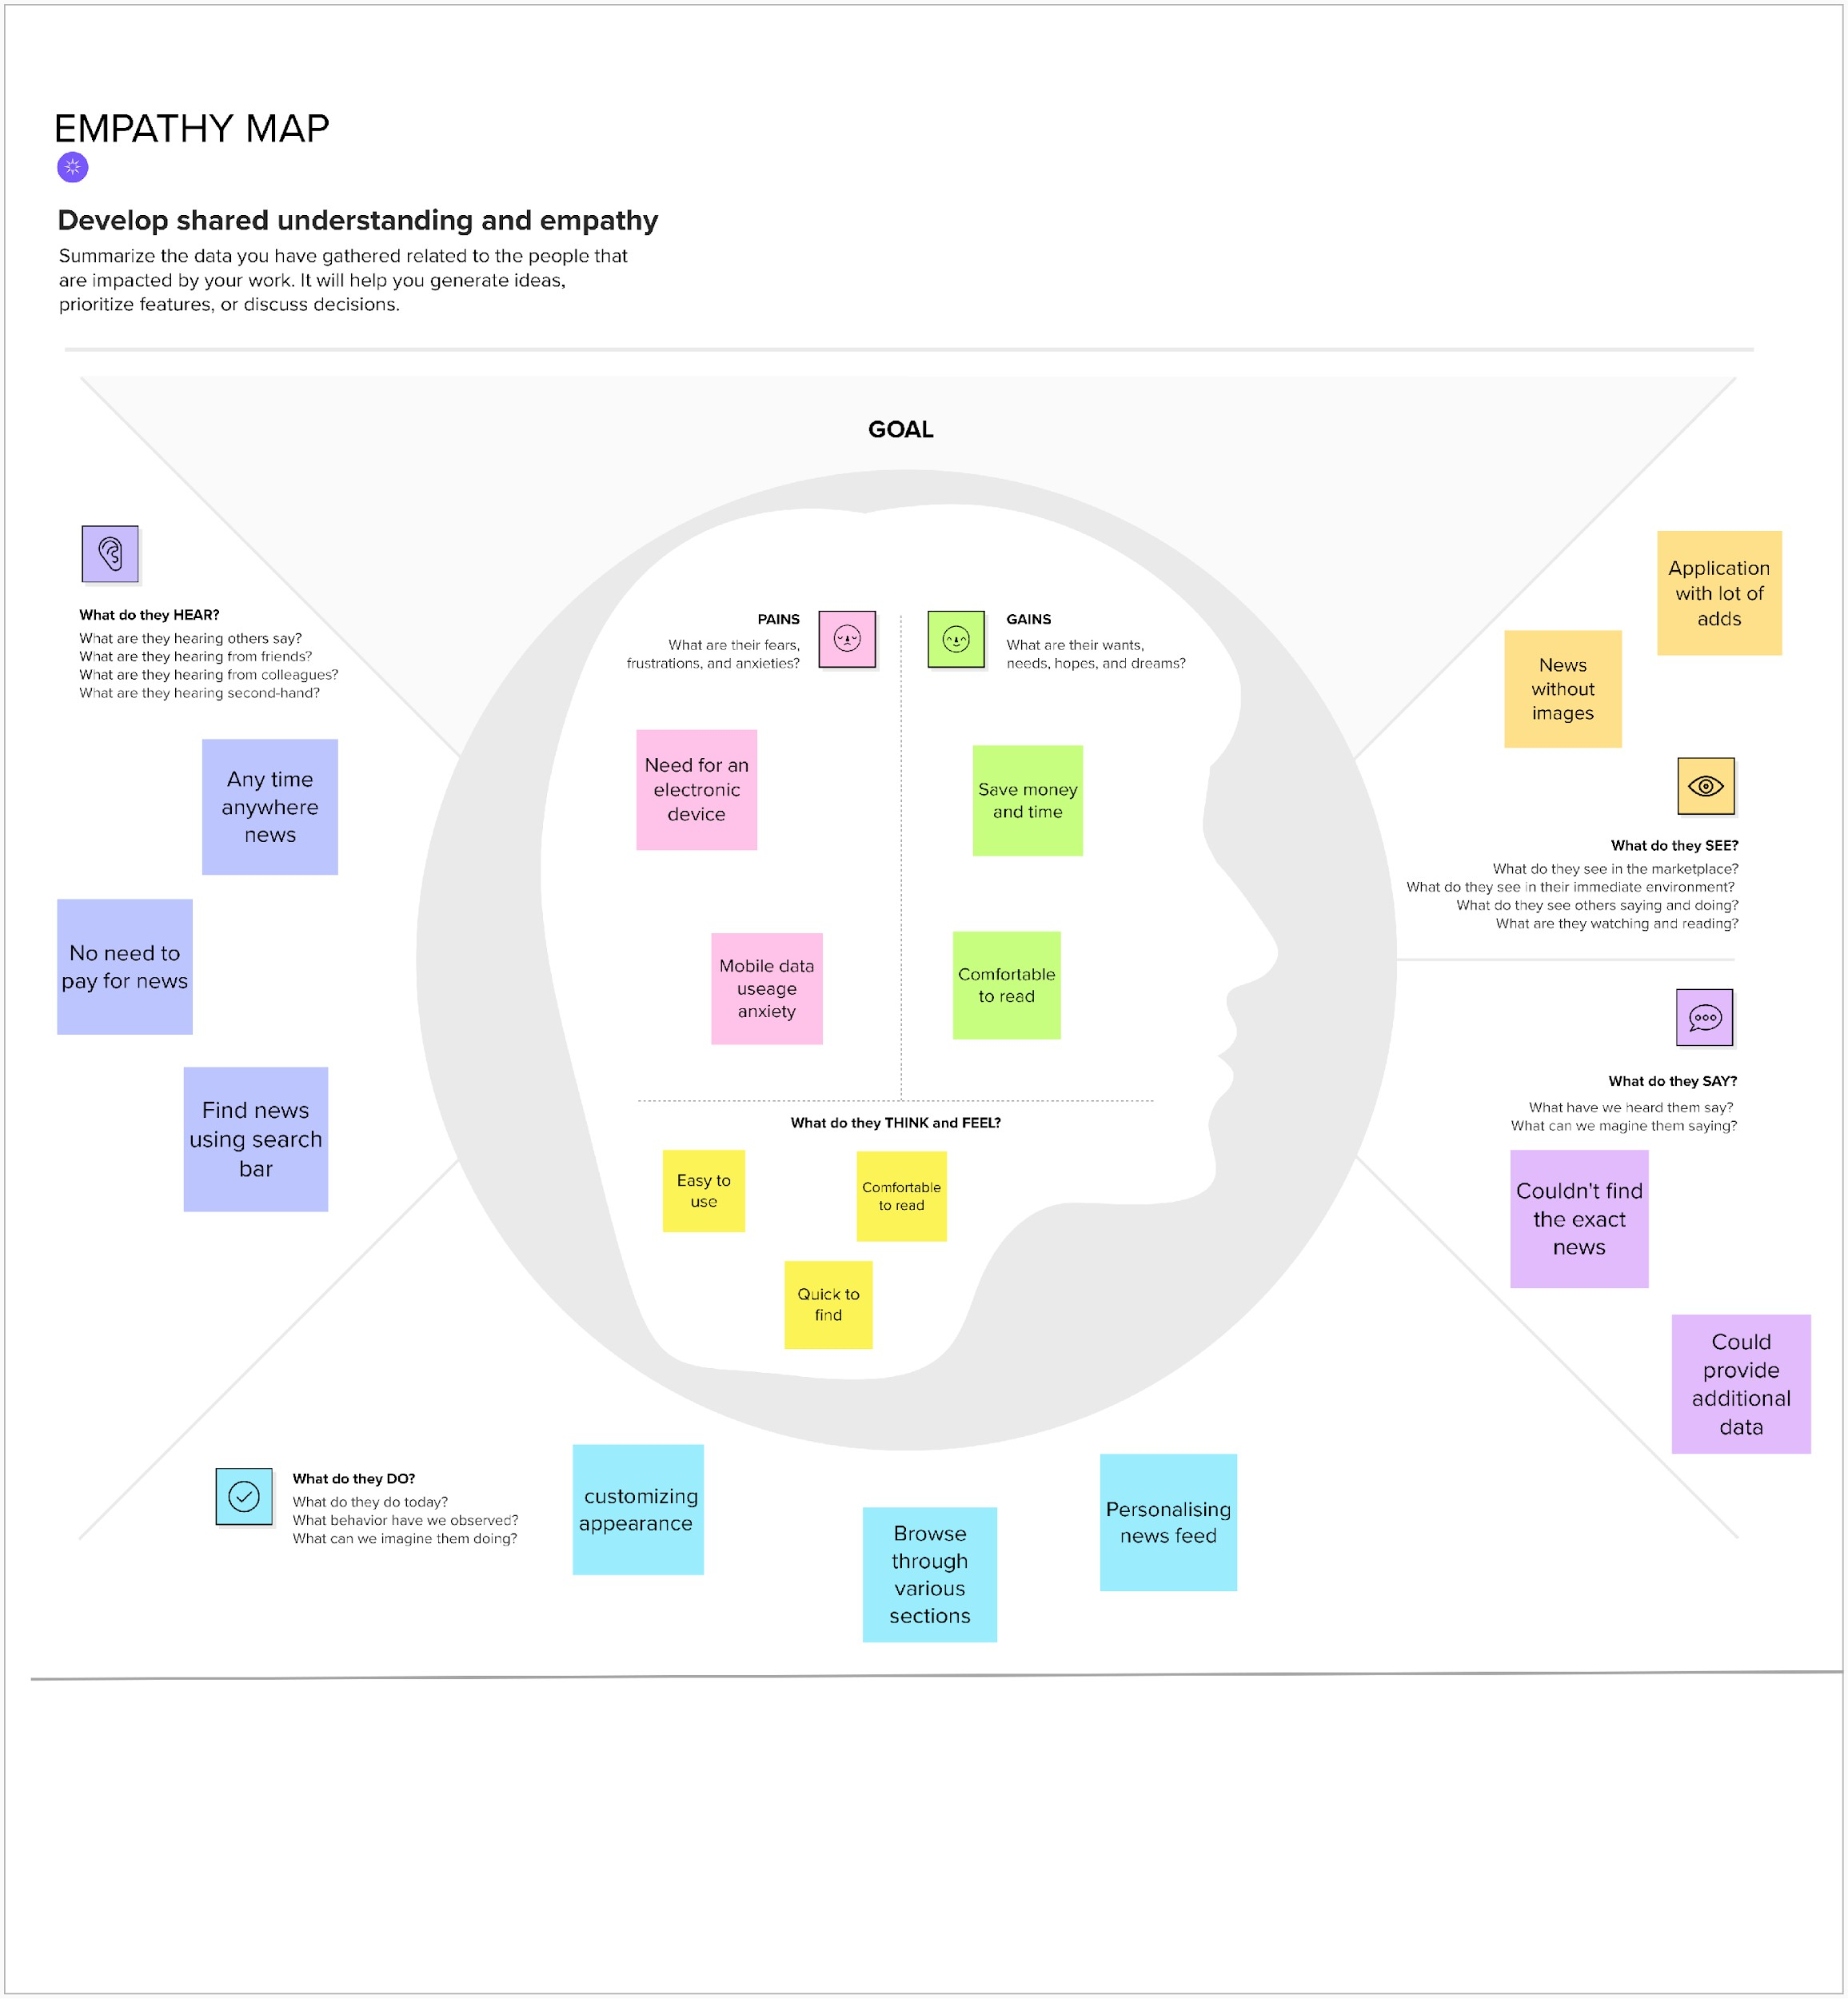**Empathy Map Canvas**

# Ideation & Brainstorming

Brainstorming provides a free and open environment that encourages everyone within a team to participate in the creative thinking process that leads to problem solving. Prioritizing volume over value, out-of-the-box ideas are welcome and built upon, and all participants are encouraged to collaborate, helping each other develop a rich amount of creative solutions.

**Step-1: Team Gathering, Collaboration and Select the Problem Statement**

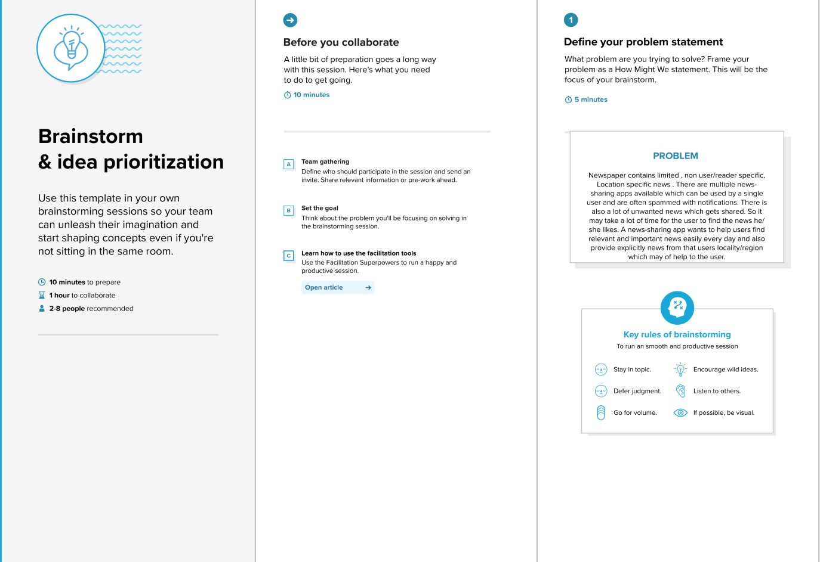

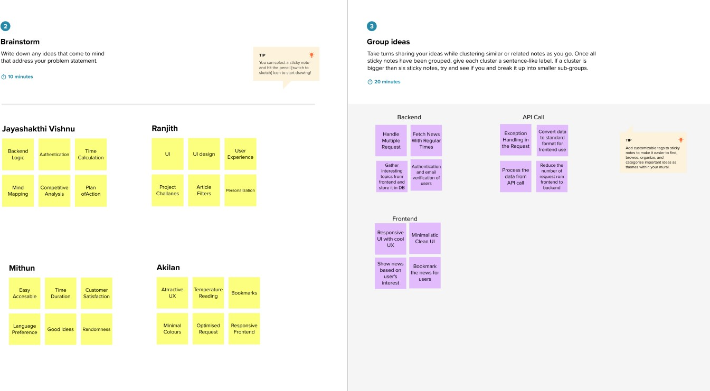**Step-2: Brainstorm, Idea Listing and Grouping**

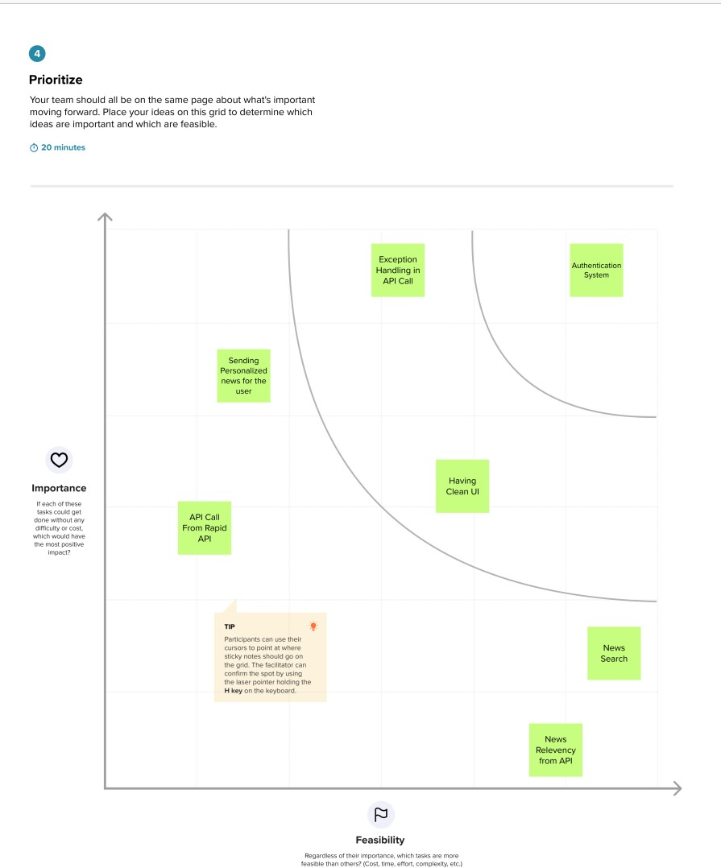**Step-3: Idea Prioritization**

# Proposed Solution

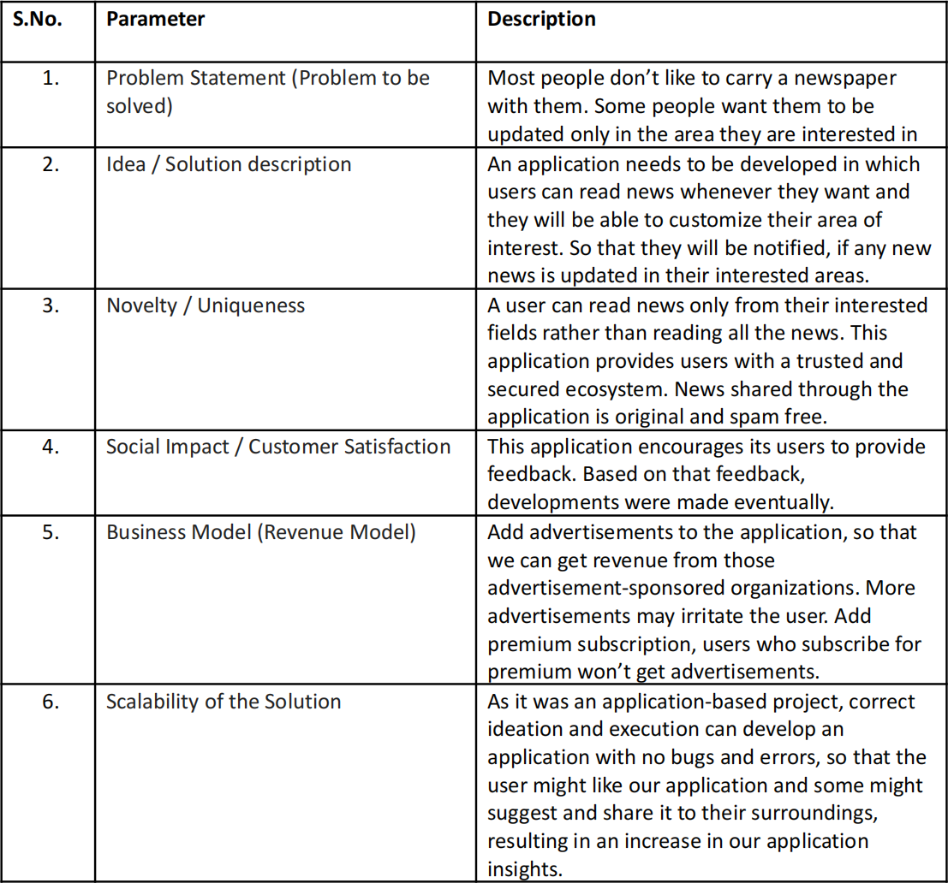

* 1. **Problem Solution fit**

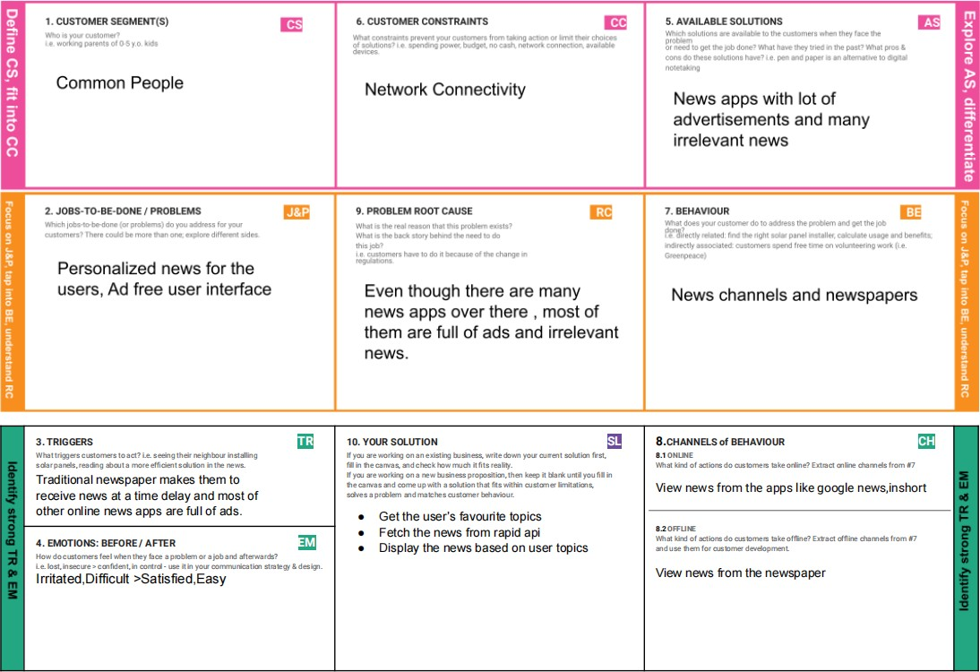

# REQUIREMENT ANALYSIS

* 1. **Functional requirement**

|  |  |  |
| --- | --- | --- |
| **FR No.** | **Functional Requirement (Epic)** | **Sub Requirement (Story / Sub-Task)** |
| FR-1 | User Registration | Registration through Email |
| FR-2 | User Confirmation | Confirmation via Email using Sendgrid |
| FR-3 | User Preffered Topics | Collecting user’s favourite topics |
| FR-4 | Collecting News | Collecting news from rapid API at regular Intervals |
| FR-5 | Bookmark | Bookmarking Favourite news for the user |
| FR-6 | Login | Loging in the user using the registered email and password |
| FR-7 | News Feed | Showing the news fetched from the API to the user |

# Non-Functional requirements

|  |  |  |
| --- | --- | --- |
| **FR No.** | **Non-Functional Requirement** | **Description** |
| NFR-1 | **Usability** | The app should be able to used by all people |
| NFR-2 | **Security** | The app should authenticate the legitimate users  and should restrict bot attacks |
| NFR-3 | **Reliability** | The app should show the news which are non fake  and spam free |
| NFR-4 | **Performance** | The app should be accessible in older devices too |
| NFR-5 | **Availability** | The app should be available to all devices |
| NFR-6 | **Scalability** | The app should handle multiple users and be designed in such a way for future upgrade |

1. **PROJECT DESIGN**

# Data Flow Diagrams

A Data Flow Diagram (DFD) is a traditional visual representation of the information flows within a system. A neat and clear DFD can depict the right amount of the system requirement graphically. It shows how data enters and leaves the system, what changes the information, and where data is stored.

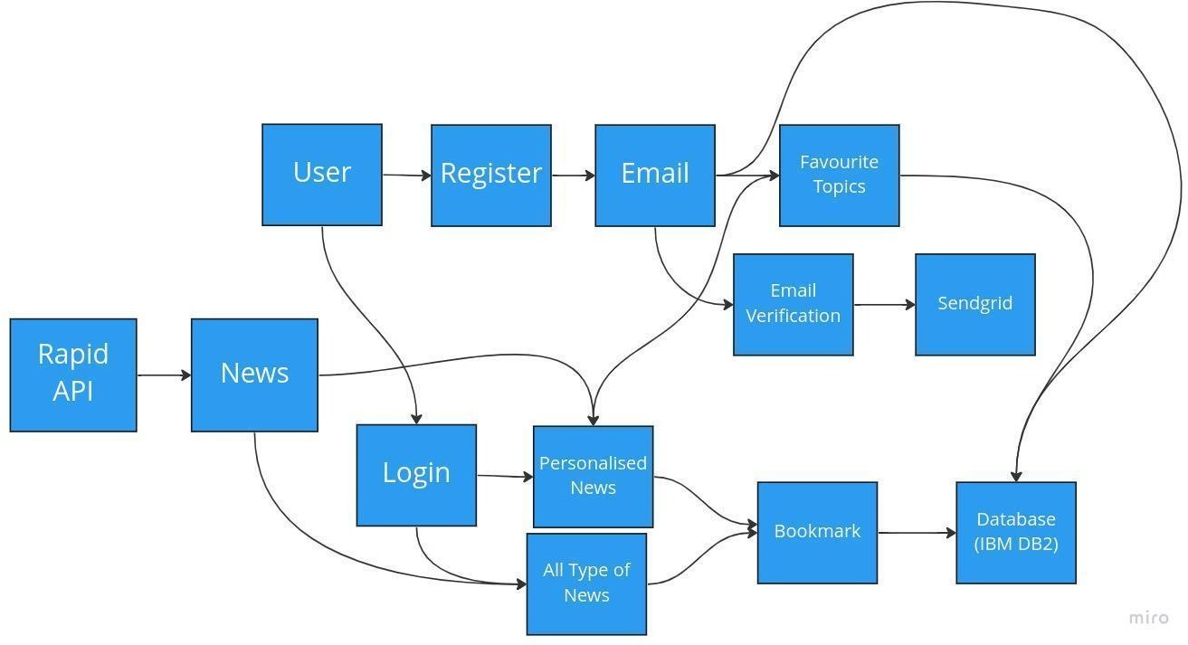

# Solution & Technical Architecture

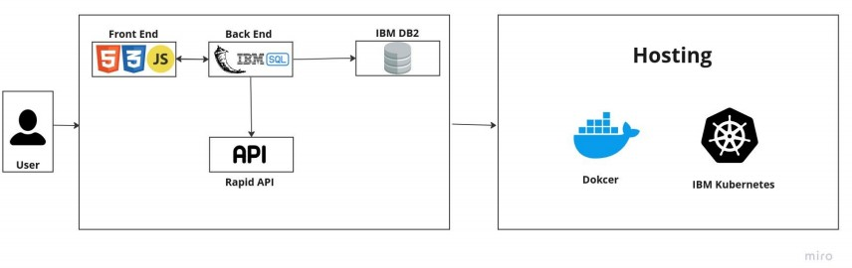

* 1. **User Stories**

|  |  |  |  |  |  |  |
| --- | --- | --- | --- | --- | --- | --- |
| **User Type** | **Functional Requirement (Epic)** | **User Story Number** | **User Story / Task** | **Acceptance criteria** | **Priority** | **Release** |
| Normal User | Registration | USN-1 | As a user, I can register for the application by entering my email, password, and confirming my password. | I can access my account  / dashboard | High | Sprint-1 |
|  | Email Verification | USN-2 | As a user, I will receive  confirmation email once I have registered for the application | I can receive  confirmation email & click confirm | High | Sprint-1 |
|  | Favourite topics | USN-3 | As a user, I can choose my  favourite topics | I can see all my  preferred news under for you category | Medium | Sprint-2 |
|  | Login | USN-4 | As a user, I can login with the email and password into the app | I can access to all the news | High | Sprint-1 |
|  | Dashboard | USN-5 | As a user, I can see all the  news under specific tab | I can view all the news | Medium | Sprint-3 |
|  | Bookmark | USN-6 | As a user, I can bookmark my favourite news topics | I can later view my bookmarked news | Low | Sprint-2 |
|  | Access | USN-7 | As a user, I can access the site anywhere and everywhere | I can view the site by typing the URL of the site | High | Sprint-4 |

# PROJECT PLANNING & SCHEDULING

* 1. **Sprint Planning & Estimation**

|  |  |  |  |  |  |  |
| --- | --- | --- | --- | --- | --- | --- |
| **Sprint** | **Functional Requiremen t (Epic)** | **User Story Number** | **User Story / Task** | **Story Points** | **Priority** | **Team Members** |
| Sprint-1 | Registeration | USN-1 | As a user, I can register for  the application by entering my email, password, and confirming my password. | 10 | High | Althaf,Gopi  Adhi,Mani |
| Sprint-1 | Login | USN-2 | As a user, I will receive  confirmation email once I have registered for the application | 5 | High | Althaf,Gopi  Adhi,Mani |
| Sprint-1 | Email  Verification | USN-3 | As a user I can verify my  email using the link sent to my mailid | 5 | High | Althaf,Gopi  Adhi,Mani |
| Sprint-2 | API Fetch | USN-4 | Fetch News from Rapid API  at regular interval | 10 | High | Althaf,Gopi |
| Sprint-2 | REST  Endpoints for backend | USN-5 | Creating endpoints at the backend inorder to interact  with frontend | 10 | Medium | Adhi,Mani |
| Sprint-3 | Designing  Frontend | USN-6 | Create a minimalisting design  in figma to create frontend | 2 | Medium | Adhi |
| Sprint-3 | Creating  Frontend | USN-7 | Create the frontend webpage  using the design | 10 | Low | Althaf,Mani |
| Sprint-3 | Connect frontend and backend | USN-8 | Connect the frontend and backend and complete the application | 8 | High | Althaf,Gopi  Adhi,Mani |
| Sprint-4 | Testing | USN-9 | Testing the application before final release | 10 | High | Althaf,Gopi  Adhi,Mani |
| Sprint-4 | Deployment | USN-10 | Deployment of the application | 10 | High | Althaf,Gopi  Adhi,Mani |

# Sprint Delivery Schedule

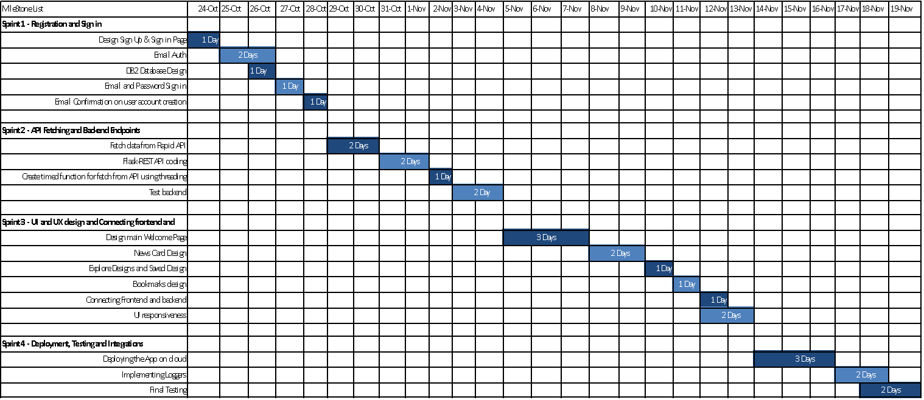

1. **CODING & SOLUTIONING (Explain the features added in the project along with code)**

# Feature 1

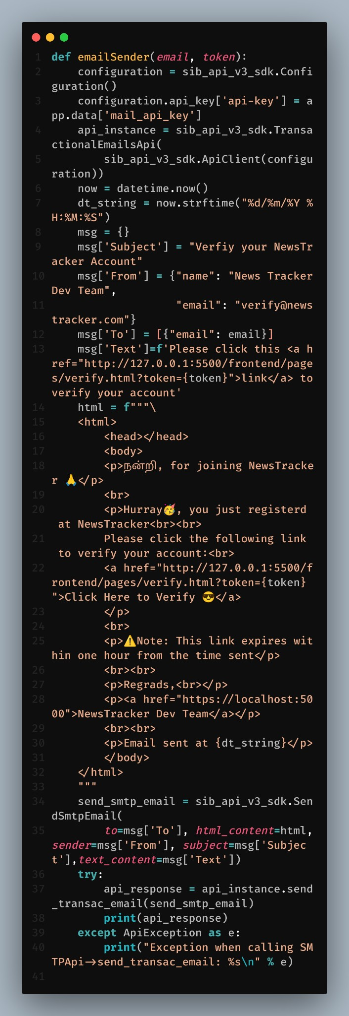**Verification email Sender**

The above function is used to sned the verification code to the desired email.

# Feature 2 Cookie Checker

This code is used to check the cookie from the client side and checks wether the user is signed in or not.

# Database Schema (if Applicable) User Table

**Bookmarks Table:**

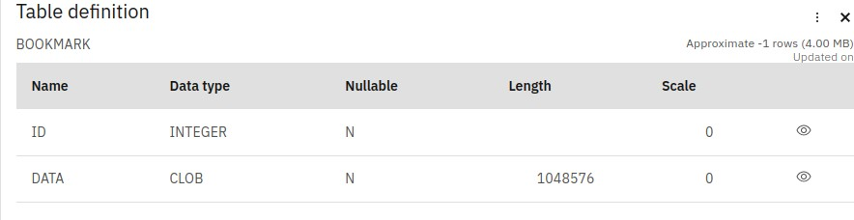

# ADVANTAGES & DISADVANTAGES

* This app can be accessed anywhere and anytime, So that the user can view the news
* Its ad free
* The news is only based on the API
* It may contain some unwanted content but we don’t have control over it
* The user can bookmark their favourite news.

# CONCLUSION

Thus we have developed a full stack application based on the plans and within the given time. We have tested the application in both desktop and mobile and it worked well, Overall it was a great experience.

# FUTURE SCOPE

In future we may integrate our own news API instead of third party APIs and may develop a mobile native application so that it can be used in both android and ios.

# APPENDIX

* [**Source Code (Github)**](https://github.com/IBM-EPBL/IBM-Project-3075-1658499328)
* [**Live Page URL**](http://159.122.183.93:31965/)